**Expert ID/Name: Nstructive**

**Date:**

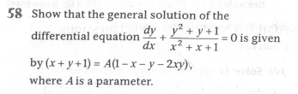

**Answer:**

|  |
| --- |
| **Section 1:** Algorithm/Theorem Reminder / A tip for solving these type of questions |
| **Tips:**   1. Separate the terms of. 2. . |

|  |
| --- |
| **Section 2:** Step-by-step answer |
| Given: Differential equation is ,  To prove: General solution of is given by  ,where A is a Parameter.  Step 1:   |  |  | | --- | --- | | Instruction | Separate the terms of . | | Calculation |  |   Step 2:   |  |  | | --- | --- | | Instruction: | Apply the integration on both sides with respect to x.  Use the formula: | | Calculation: |  |   Step 3:   |  |  | | --- | --- | | Instruction | Use the formula: | | Calculation | Put then. | |

|  |
| --- |
| **Section 3:** |
| Conclusion: : General solution of is given by  ,where A is a Parameter.  Hence, proved.. |